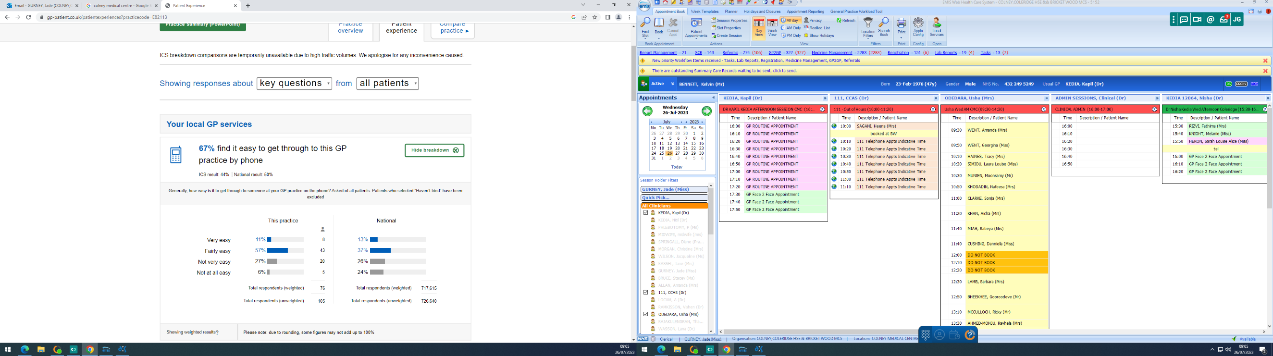
Practice Response/Action Plan:

The Practice now has a cloud-based telephone system which allows for a call queueing facility and a call back facility. The Practice currently sits above the local and national averages. We will continue to monitor phones at our busiest times and will ensure we have enough staff to answer phones efficiently.

