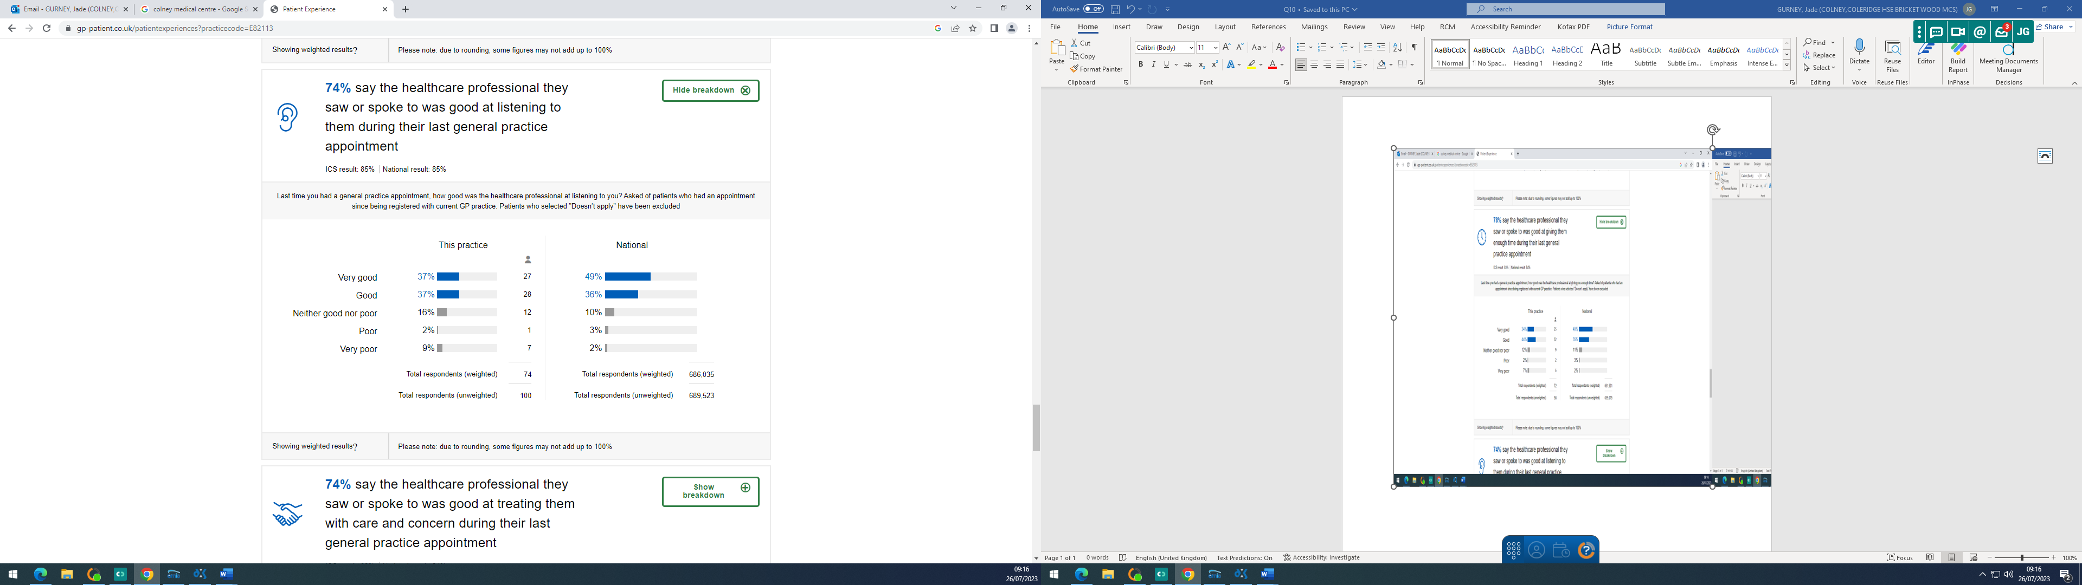

Practice Response/ Action Plan:

The practice is below both local and national averages. We have recently taken on new locum Dr’s and we hope that this will remedy this particular question.

