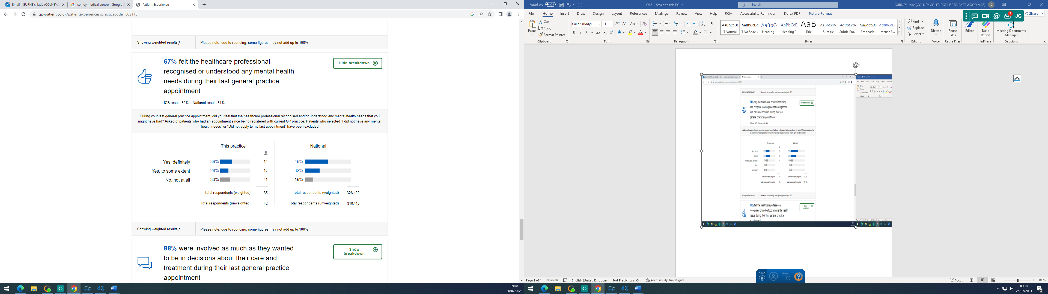

Practice Response/ Action Plan:

The practice is below both local and national averages. The practice is currently recruiting a Mental Health Practitioner who will be well versed in their field. This will allow patients to be directed straight to this professional who is better equipped to deal with Mental Health.

