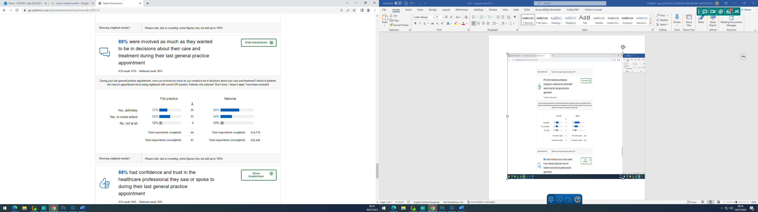

Practice Response/ Action Plan:

The practice is slightly below both local and national averages. The practice and its staff endeavour to always listen to patients re their health concerns and discuss the best possible treatment and outcomes that may suit.

