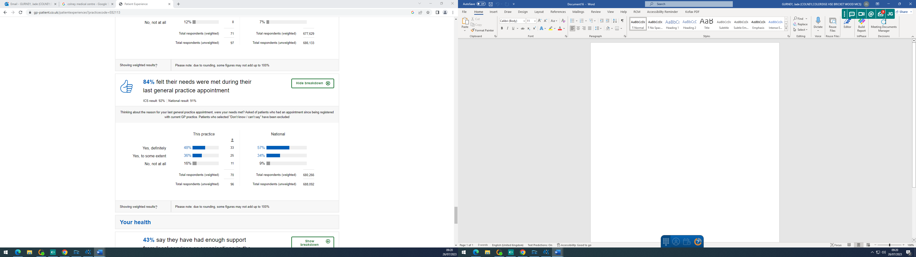

Practice Response/ Action Plan:

The practice is slightly below the local and national averages. Patients are encouraged to make follow up appointments if not every problem can be discussed at the initial appointment. The practice also plans to expand its workforce to ensure patients are triaged to the correct Clinician when they first contact the surgery.

