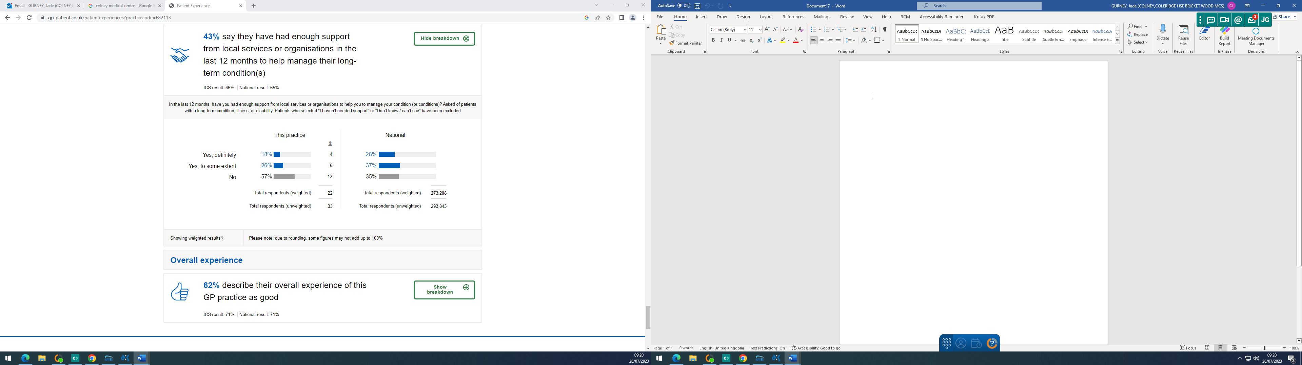

Practice Response/ Action Plan:

The practice is below local and national averages. We have a Social Prescriber who actively supports patients with long term health conditions. The practice will continue to ensure that her priority remains educating this cohort of patients to ensure the best possible care.

