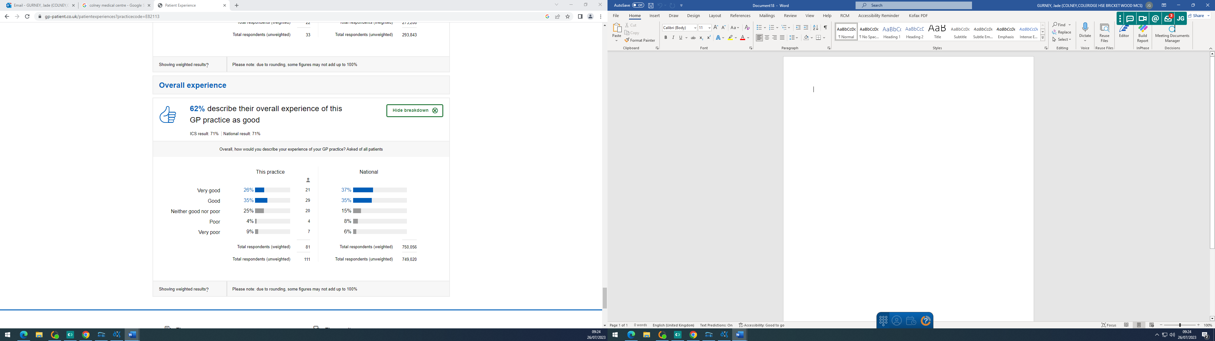

Practice Response/ Action Plan:

The practice is below the local and national average. The practice will continue to listen to patient feedback to help to continue to improve our service.

