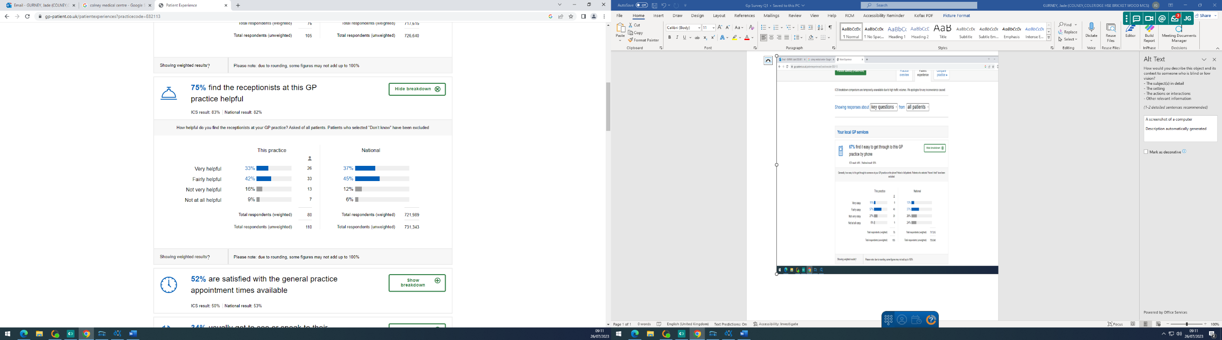

Practice Response/ Action Plan:

The practice is broadly in line with the local and national averages. This finding is in line with our desire to offer a helpful reception service to our patients. The practice has invested in training on customer satisfaction and managing conflict resolution for our reception team.

