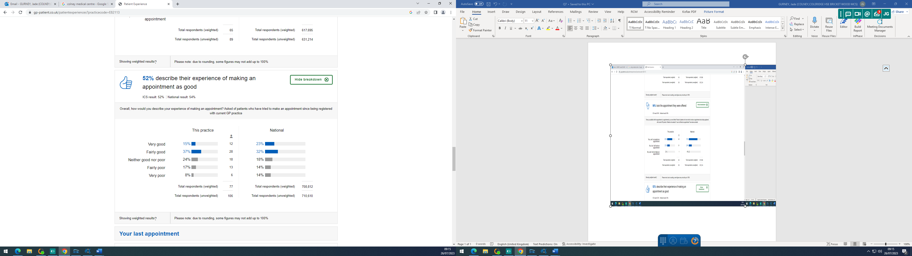

Practice Response/ Action Plan:

The practice is inline with local and just below national averages. The practice will continue to offer the best possible service to our patients and continue to ensure that they have a straight forward and easy experience when making an appointment.

